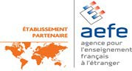
TELOPEA PARK SCHOOL
LYCEE FRANCO-AUSTRALIEN DE CANBERRA

Year 10 STUDENT / PARENT / CARER INFORMATION SESSION

2020 AND BEYOND
For all 2019 Year 10 Students and Parents/Carers

Topics covered include:
College enrolments, ANU extension program, UC courses and pathways, CIT, ADFA, Student Pathways, Year 10 Certification, Career Development at Telopea Park School

DATE: THURSDAY 9th MAY
5.30pm -6.30pm in the HALL

