Dear Parents/Carers,
Yesterday morning I met with a small group of parent representatives regarding concerns about the proposed timetable we would like to implement for the start of 2024. I provide additional information in this publication in the hope that it allays some of the concerns raised by parents/carers.
Why were the changes proposed?
Changing the current timetable was initially considered after comments made over time by students, staff and parents/carers. This was not a formal process but it did lead us to reflecting on the complexity of the current timetable and limitations it created, particularly in relation to the sharing of human resources. Staff were surveyed and their responses led to investigation of potential alternate models. From these, a preferred model was selected as it would:
- provide opportunities for secondary classes and programs (e.g. Peer Support) to work with students in the primary area, promoting leadership opportunities for students and development of positive relationships through structured and supervised lessons
- allow us to maintain the broad range of learning opportunities for students in both primary and secondary
- have negligible impact on student learning;
  - Specialist areas in the primary area have been reduced by 7 or 8 mins per week, however, as mentioned in the FAQ sheet, consolidation of the specialist content and skills also occurs during general primary class time, which would increase by 5 minutes per day.
  - In secondary, while learning time per day and per line would decrease, this would be offset in part by an increase in Interdisciplinary Unit (IDU) time by 30 hours per year, increasing multidisciplinary learning that would provide increased opportunities for students to engage in real world concepts and issues, such as sustainability, in global contexts.
  - The proposed changes are supported by the secondary French team and accommodations made to assist students to manage the work commitments of the bilingual learning program.
- provide added flexibility through a ‘rolling line’ in secondary. The initial plan has been changed, with the ‘rolling line’ now moved to Monday to allow additional time in Contact Groups, providing time to work on our Strategic Priority: To strengthen student connectedness to the school community.
- to reduce unstructured break time and change the timings of students playing outside to better align with Sun Smart practices. In response to parent/carer concerns regarding the proposed change to the school end time, breaks have been increased to maintain a 3:15p.m. end of school day.
- provide flexibility in human resourcing (with common breaks and a number of common lessons across primary and secondary, we can better utilise teachers and learning support assistants across the school, particularly in times of teacher shortage – where feasible, we can use teachers in both primary and secondary areas of the school
- increase opportunities for students to access public transport to and from school
- allow less complex implementation of changes to teacher’s working conditions as outlined in the recently negotiated Enterprise Agreement.
Common Break Times and Sharing the Playground
As mentioned, the proposed timetable provides improved flexibility for teaching and support of students along with greater opportunities for collaboration between primary and secondary classes through alignment of lesson and break times.
To provide clarity, and hopefully some reassurance, apart from organised activities, primary and secondary students will not be sharing playground spaces. On the following page is a map of the playground areas that will be implemented. It is worth noting that:
- playground supervision will not be reduced through the implementation of the new timetable
- primary and secondary students will maintain specifically allocated toilets – these are not shared between primary and secondary students
- Montgomery Oval will provide an additional secondary play space as it did during COVID cohorting
- the installation of a secondary artificial turf field will mean that the primary one will not be used by secondary students during break times
- with the exception of the previous two dot points, what has been proposed in relation to the playground is the same as what currently happens for 2 hours and 15 minutes each week.
- during periods of teacher shortage we prioritise playground supervision as it is a less structured time for students.
While we are confident that our assessment of the potential risks and mitigations provided through our processes and procedures, we will undertake a review of playground supervision ratios in response to concerns raised. I have also requested assistance from the Education Directorate to review our risk identification and mitigations.
I recognise that implementing changes to the learning and play arrangements for students is significant and that some of the parent concern has stemmed from the lack of detailed information from the school. I apologise that our process and lack of timely and detailed information has caused distress to members of our community. I will endeavour to learn from this experience and am hopeful that the information offered in this publication provides you with confidence that the proposed changes have been carefully considered and will be of benefit to the school and our students.
In moving forward, we will implement the proposed timetable changes for the start of 2024. During the remainder of this year we will dedicate time to the finer details of the model and share these with you as early as possible. We commit to monitoring the implementation and adjusting where necessary to continue to provide quality learning and a safe school environment for students. We will seek parent/carer, staff and student feedback on the changes towards the end of Semester 1 2024.
Regards,

Jason Holmes
Principal

Map of Playground Zones for Primary and Secondary Students
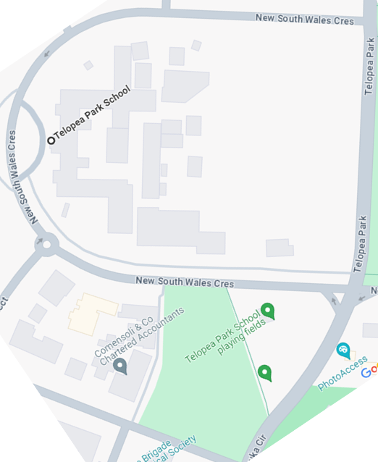
Key
Colour | Students Allocated to Playground Area
 | Kindergarten
 | Year 1, Year 2
 | Years 3 - 6
 | Primary / Secondary boundary (virtual)
 | Secondary
Primary students can also access the primary library during breaks. Secondary students can access the secondary library during the breaks.

